Beta, Gamma, & Normal Distribution

Part One - Normal Probability Distribution:

Normal Probability Distribution is a distribution where if the standard deviation is above 0 and the mean is between negative infinity and infinity, then find the density function of Y by using the equation:

$f(y)=\frac{1}{σ\sqrt{2π}}e^{-{(y-μ)}^{2}/(2σ^{2})}, -∞<y<∞$

In order to find the Normal Probability Distribution, you need to know both the standard deviation and the mean, while also understanding how e plays into the equation. According to this graph:

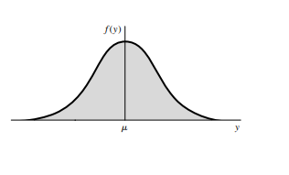

Any area under the $P(a≤Y≤b)$ would need to be evaluated through integrals, but it also needs to be evaluated through numerical integration techniques, as a closed-form does not exist for the integral needed for the equation. Normal density function is also symmetric around the standard deviation, so when finding the areas they only need to find the one side of the standard deviation and the mean, which are usually shown as Z. This is what is shaded in the above graph. So if you were if you were trying to find $P(-2≤Z≤2)$ you would start on either the right or left side, find what area you are looking for, and then shade the other side in a symmetrical way. This would look something similar to this graph:

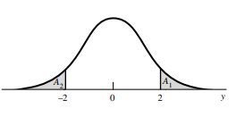

Another way to use this equation that is easier to understand would be:

$Z = \frac{y - μ}{σ}$

In order to use it this way, however, you must have a range of values to work with for both sides of the graph and would need to use the equation twice, one for each side of the graph.

Part Two - Gamma Distribution:

Gamma Distribution is used when you have random variables that are always nonnegative, but are usually skewed, or nonsymmetric, to the right of the graph. The best example of this would be trying to keep track of people arriving at a store, usually more people show up closer to the opening time and less as the day goes on, so the graph would be skewed to the origin. For gamma distribution, the density function of Y would have to be:

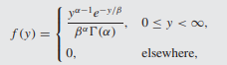 where: 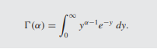

When trying to find the mean and the standard deviation of a gamma distribution, you would need to take the parameters and times them. Gamma distribution is mostly used to show that two parameters are less than or greater than a certain value.

Part Three - Beta Distribution:

Lastly, beta distribution is a two-parameter distribution with a closed interval of $0≤y≤1$ and is mostly used for proportions. The density function of Y must be:

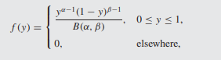 where: 

Depending on what the two parameters of $α$ and $β$ the graph can look extremely different. There is also an incomplete beta function, usually used when trying to find the cumulative distribution of a random variable. This distribution is usually used to find the probability that something will be at least a given percentage or range. It is also possible to use software to find the probabilities of using the beta distribution. This is found on the Thomson website and it gives “upper-tail” probabilities that are associated with beta random variables. The textbook also agrees that this is by far the easiest way to find and use beta distribution. Lastly, the best example of how to use this distribution in the real world would be trying to predict how much stock would be sold from a store, granted you know what the parameters would be and what percentage of the stock should be gone in that given time period.